**REQUIREMENT VIEWS**

* Requirements Tree

It’s the default look, Shows Child-Parent relations of the requirements

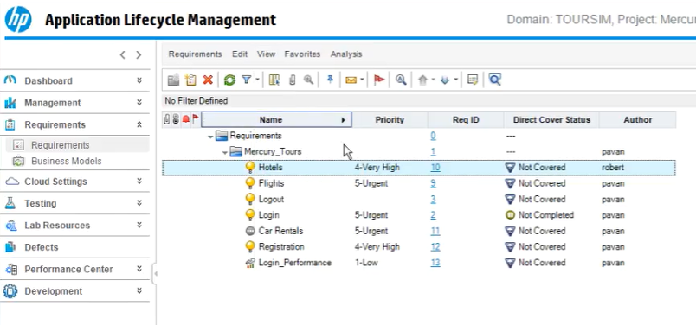

In order to open a specific requirement detail page you have to select and double click to open

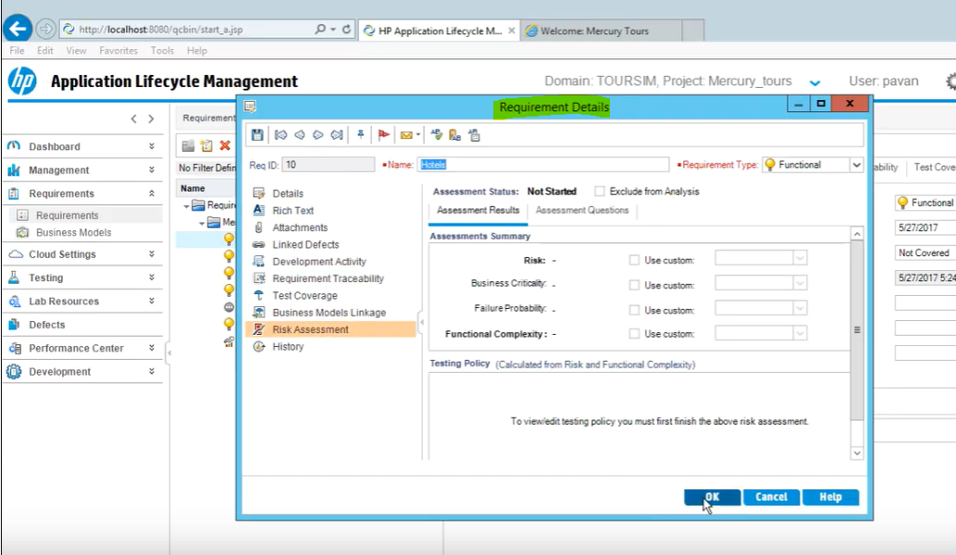

Then when you want to review details for another requirement details you need close the first one then, go open the second one.

To avoid this, we can change the view to requirement details.

* Requirement Details View

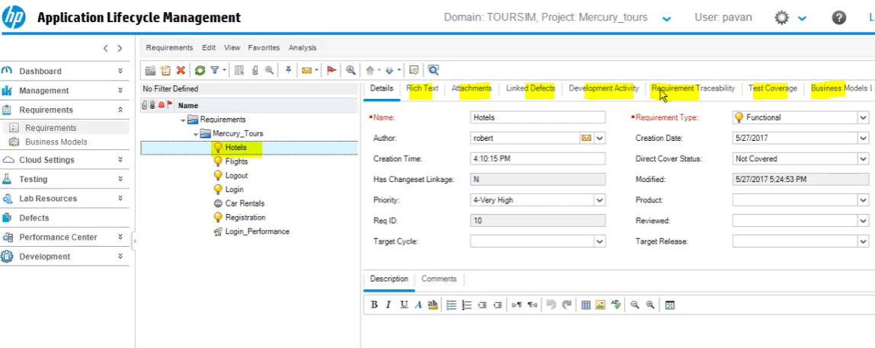

By one click you can see requirement details and other modules in the requirement

* Requirement Grid View

Its mainly used to search something fast such as

* Urgent Priority requirements
* Requirements created by a person
* Not completed requirements

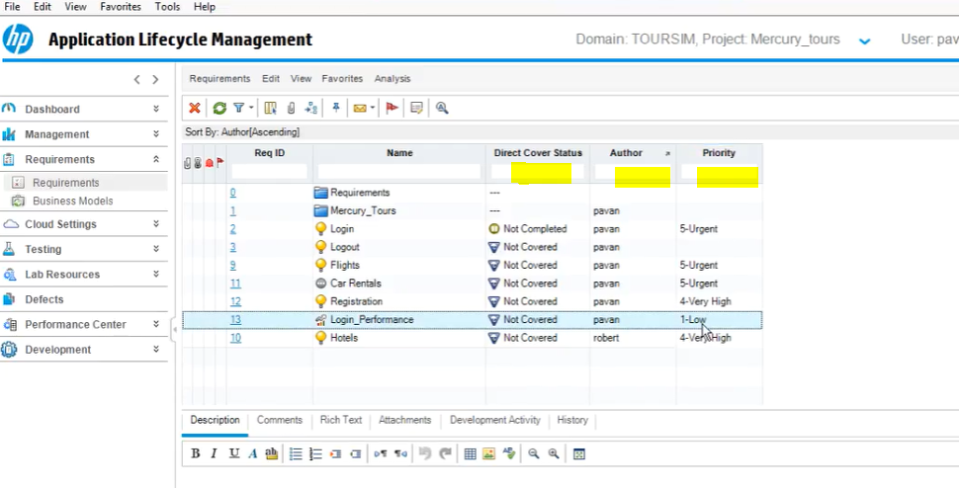

You can simply click on the box and enter your filter word

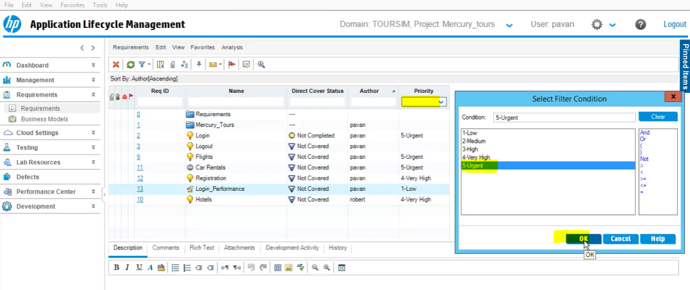

Click ok

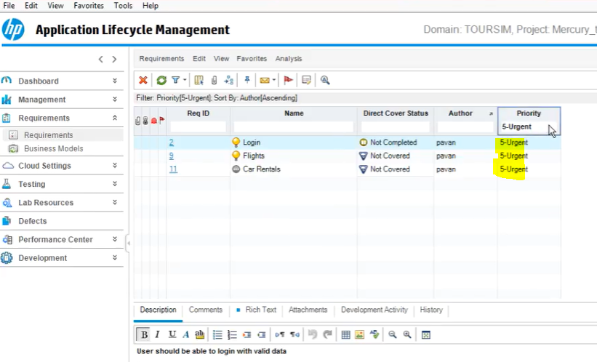

* Coverage Analysis View

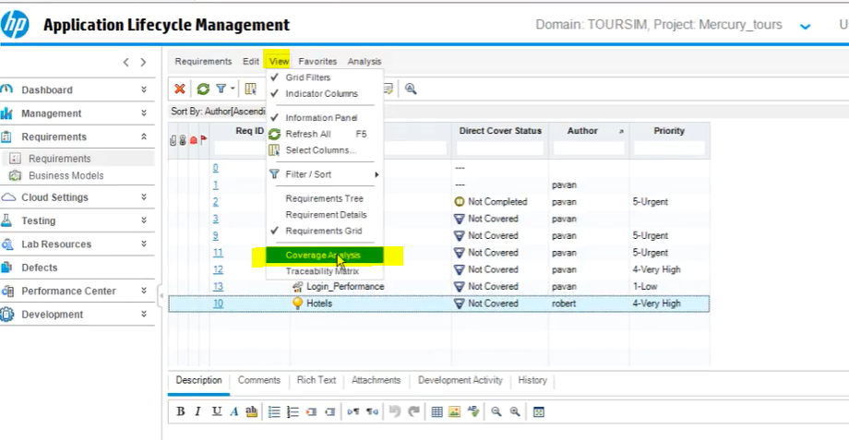

This is the coverage analysis view

Click on legend you will see coverage details

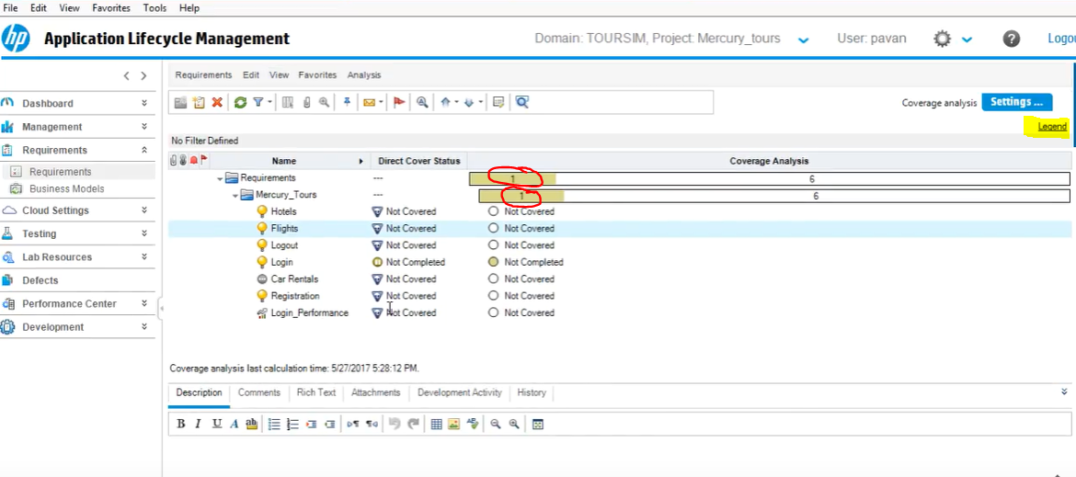

When you click on numbers it will open a window showing you the detailed coverage as well

